Data-Driven Assessment of Surface Post-Processing Effects on Fatigue Life of Additively Manufactured AlSi10Mg
By: Erfan Maleki
Program: Professional Certificate in Machine Learning & Artificial Intelligence – University of California, Berkeley
Date: Jan 2026

1. Business and Engineering Problem
Fatigue failure is a primary barrier limiting the widespread adoption of additively manufactured (AM) metal components in safety-critical industries such as aerospace, automotive, and energy.
While surface post-processing treatments are known to significantly improve fatigue performance, selecting the optimal treatment remains expensive, time-consuming, and highly empirical.
This capstone addresses the problem by applying data-driven machine learning methods to quantify how surface-induced variations—including roughness, residual stress, hardness, and microstructural characteristics—affect the fatigue life of LPBF AlSi10Mg components.
The goal is to replace trial-and-error testing with interpretable, predictive insights that support engineering decision-making.

2. Research Question
How do surface-induced variations in surface texture, residual stress, microstructure, and mechanical properties—introduced by different post-processing treatments—govern the fatigue life of LPBF AlSi10Mg, and which features are most predictive across varying stress regimes?

3. Dataset Description and Organization
The dataset originates from a peer-reviewed study:
Maleki, E., & Shamsaei, N. (2024). A comprehensive study on the effects of surface post-processing on fatigue performance of additively manufactured AlSi10Mg. Additive Manufacturing, 86, 104179.
https://www.sciencedirect.com/science/article/pii/S2214860424002252

Dataset Characteristics
- 88 fatigue test conditions
- 21 surface post-processing treatments
- Four stress amplitudes
- Fully controlled LPBF and post-processing conditions

Feature Groups
- Mechanical properties: Yield strength, ultimate tensile strength, elongation
- Surface characteristics: Roughness (Ra), hardness, hardness depth
- Residual stress: Surface CRS, maximum CRS, CRS depth
- Defect metrics: Porosity and pore-closure depth
- Loading condition: Stress amplitude
- Target variable: Fatigue life (cycles to failure)

4. Data Preparation and Cleaning
All data were cleaned and standardized prior to analysis:
- Column names normalized
- Numeric features scaled where required
- Missing values imputed using median statistics
- Outliers retained intentionally due to physical relevance
This ensures reproducibility, model stability, and interpretability.

5. Exploratory Data Analysis (EDA)

5.1 Distribution of Key Variables

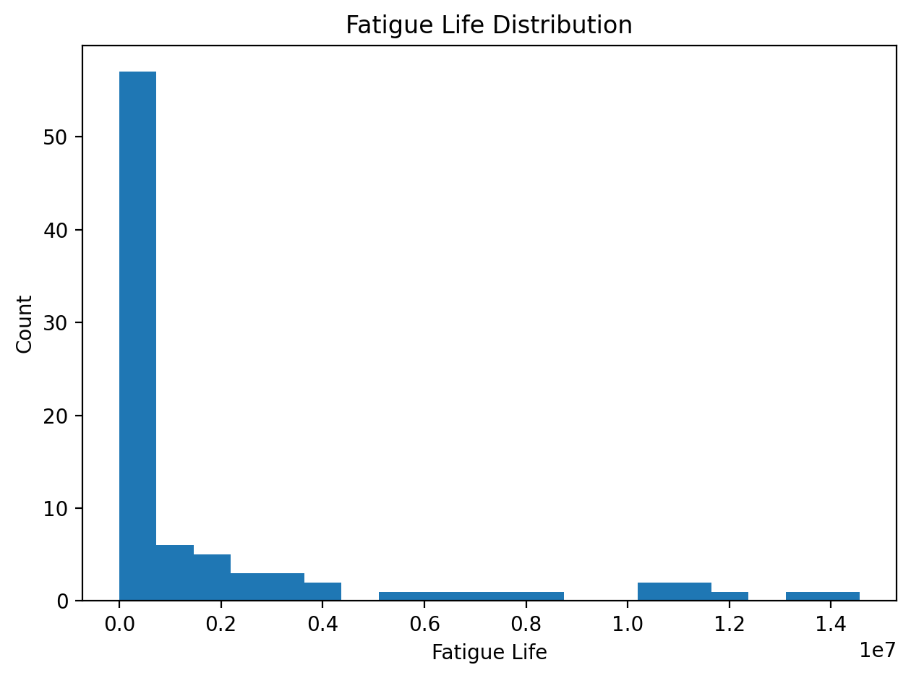
Figure 01. Distribution of fatigue life.
Figure 01 shows the distribution of fatigue life across all tested conditions, highlighting a wide range spanning multiple orders of magnitude. This broad distribution reflects the strong influence of surface condition and loading regime on fatigue performance and motivates the use of log-scaled and nonlinear modeling approaches.
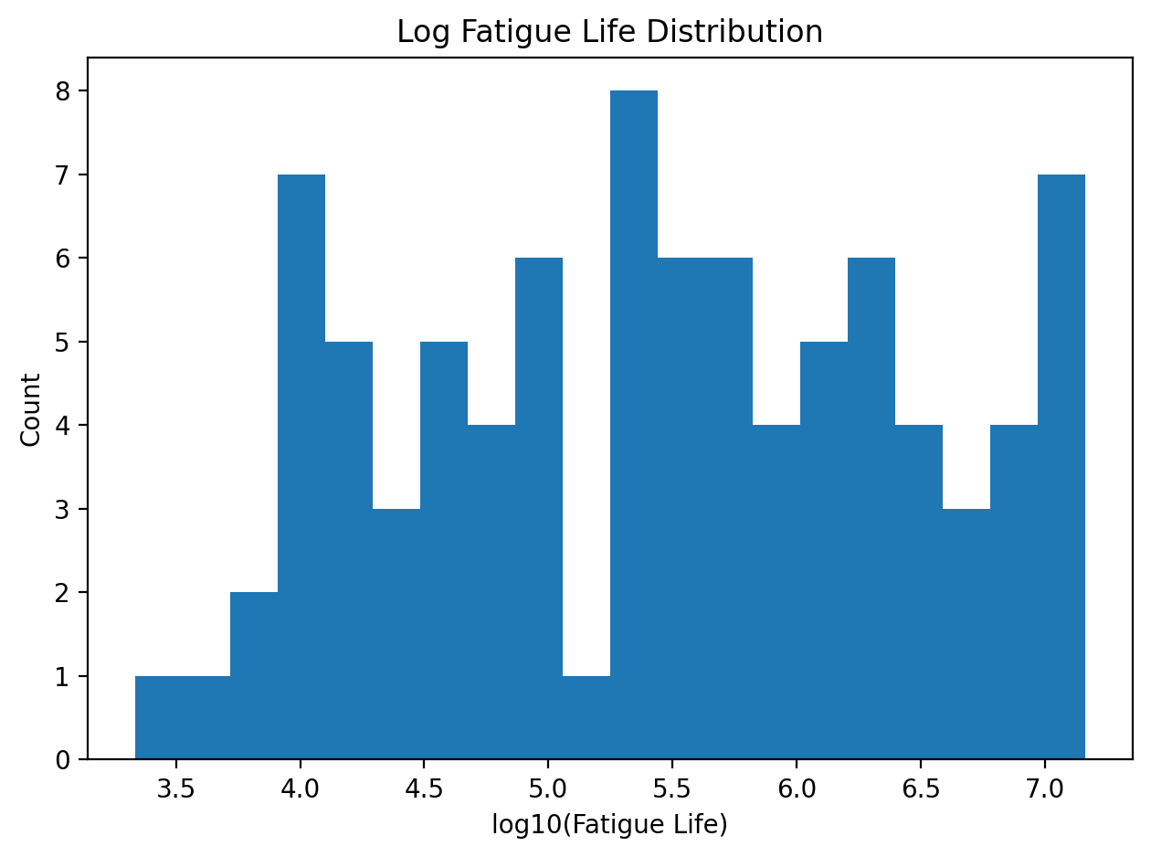
Figure 02 – Log-Scaled Fatigue Life Distribution
Figure 02 presents the fatigue life distribution on a logarithmic scale. The log-scaled representation reveals the multi-order-of-magnitude spread in fatigue life that is not apparent on a linear scale. This confirms that fatigue behavior in LPBF AlSi10Mg is inherently nonlinear and motivates the use of nonlinear regression and ensemble machine-learning models.
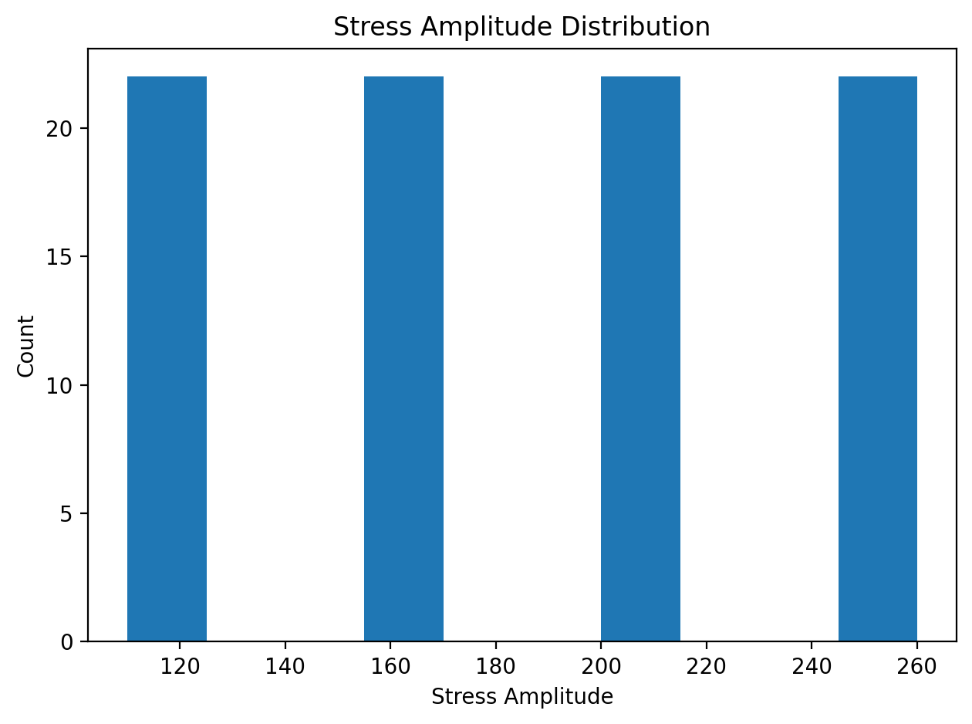
Figure 03. Distribution of stress amplitude.
Figure 03 presents the distribution of applied stress amplitudes, confirming that fatigue tests were conducted at discrete, controlled loading levels. This controlled design enables fair comparison of fatigue performance across different surface post-processing treatments.
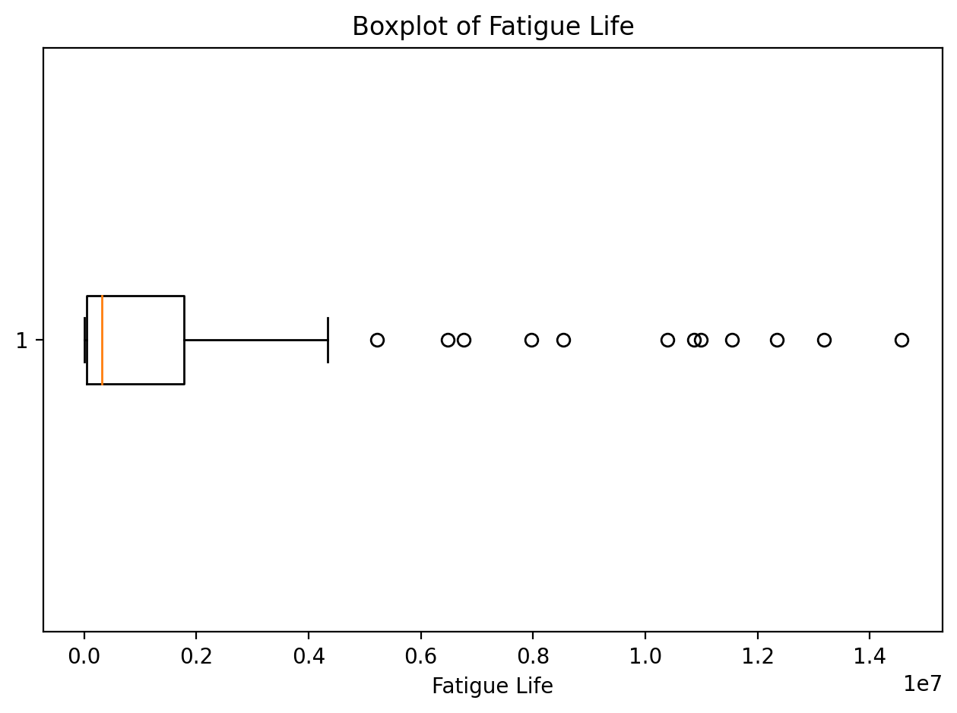
Figure 04. Boxplot of fatigue life.
Figure 04 illustrates the dispersion and variability of fatigue life using a boxplot representation. The presence of outliers reflects physically meaningful extreme responses rather than experimental error, often associated with surface defects or particularly effective post-processing treatments.

5.2 Relationships Between Variables

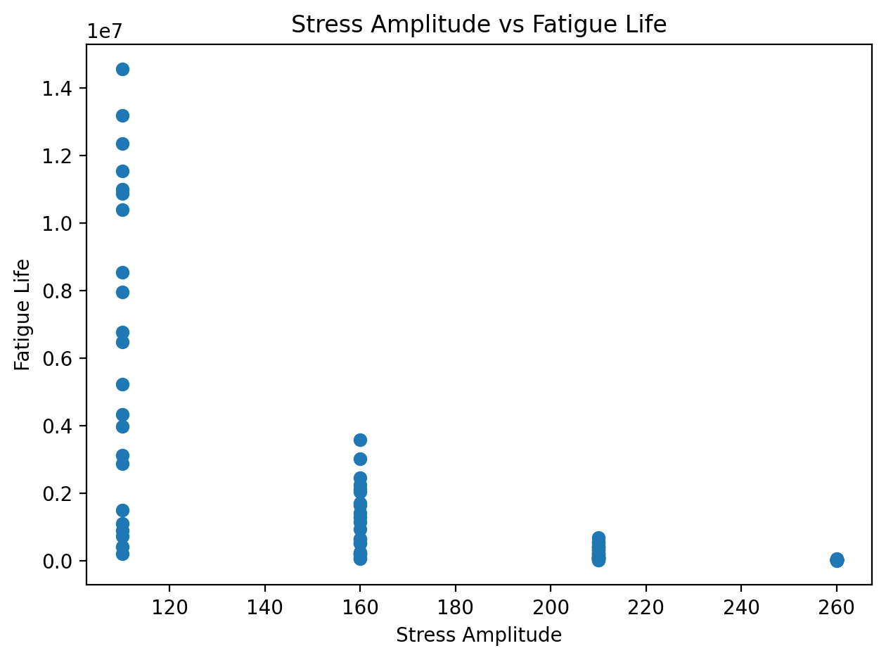
Figure 05. Stress amplitude versus fatigue life.
Figure 05 demonstrates a strong inverse relationship between applied stress amplitude and fatigue life, confirming classical fatigue behavior. Higher stress levels lead to significantly reduced fatigue life regardless of surface condition.
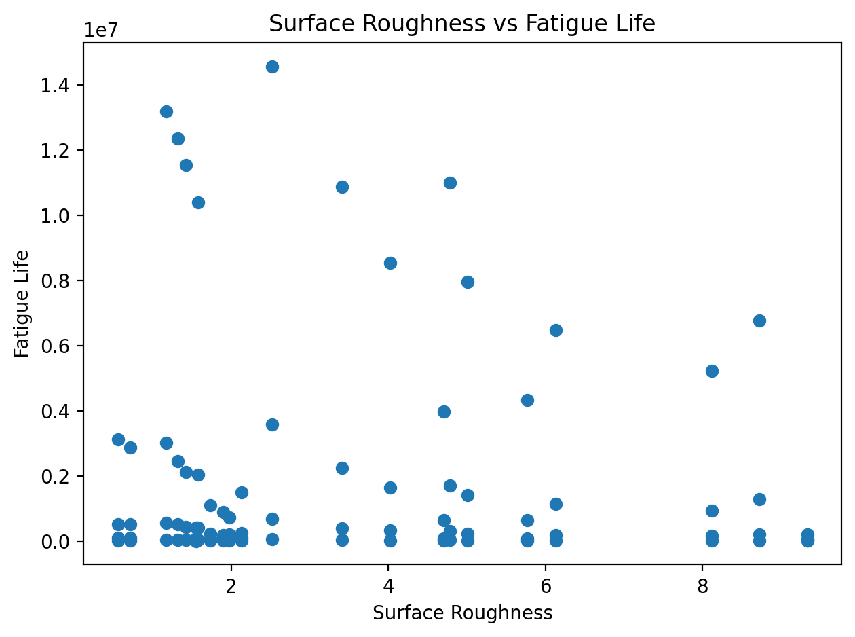
Figure 06. Surface roughness (Ra) versus fatigue life.
Figure 06 shows that increased surface roughness is associated with reduced fatigue resistance. Rough surfaces promote early crack initiation by acting as stress concentrators, highlighting the importance of surface finishing in AM components.
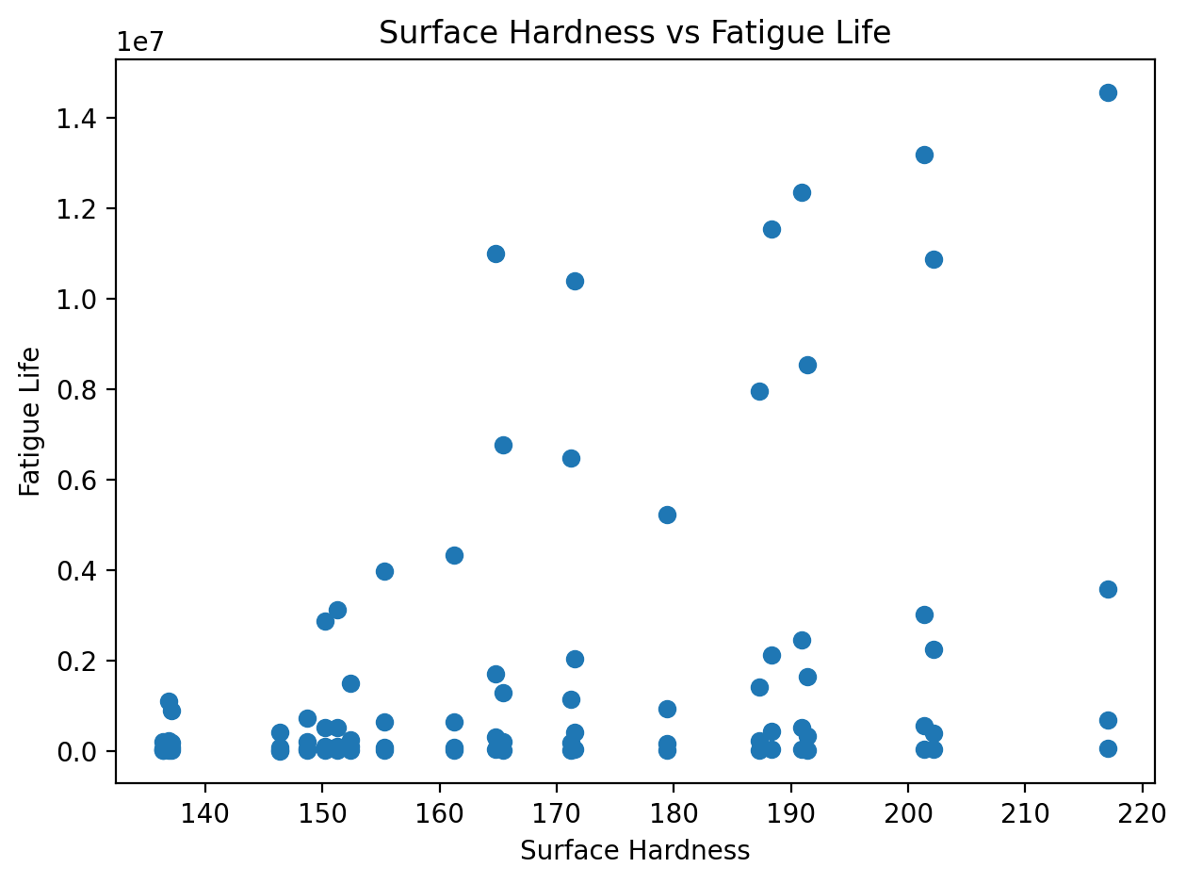
Figure 07. Surface Hardness vs. Fatigue Life
Figure 07 illustrates the relationship between surface hardness and fatigue life. While increased surface hardness generally correlates with improved fatigue performance, the scatter indicates that hardness alone is insufficient to fully predict fatigue life. This highlights the need to consider surface roughness, residual stress, and loading conditions simultaneously.
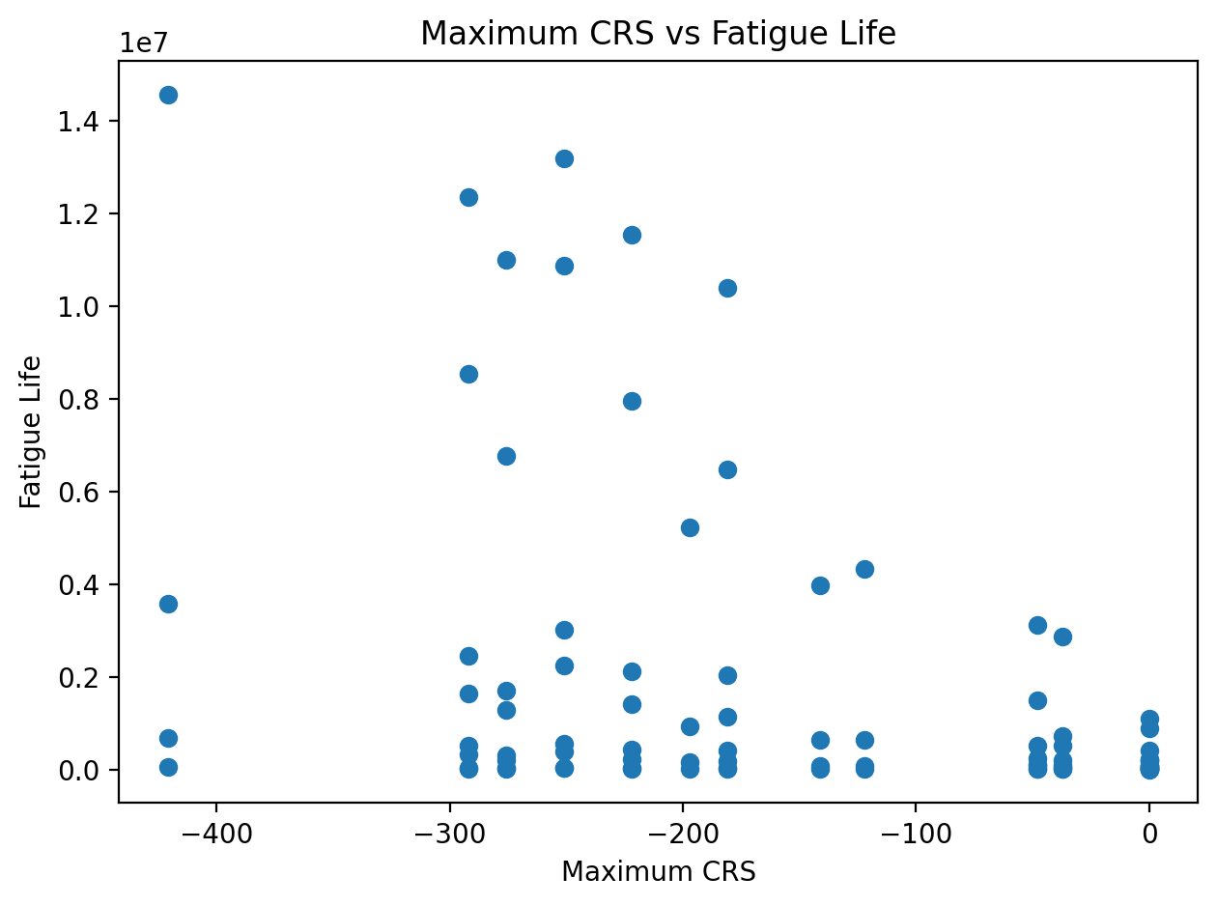
Figure 08. Maximum compressive residual stress versus fatigue life.
Figure 08 confirms that higher compressive residual stress correlates with improved fatigue performance. Compressive residual stresses counteract applied tensile loads and delay crack propagation.
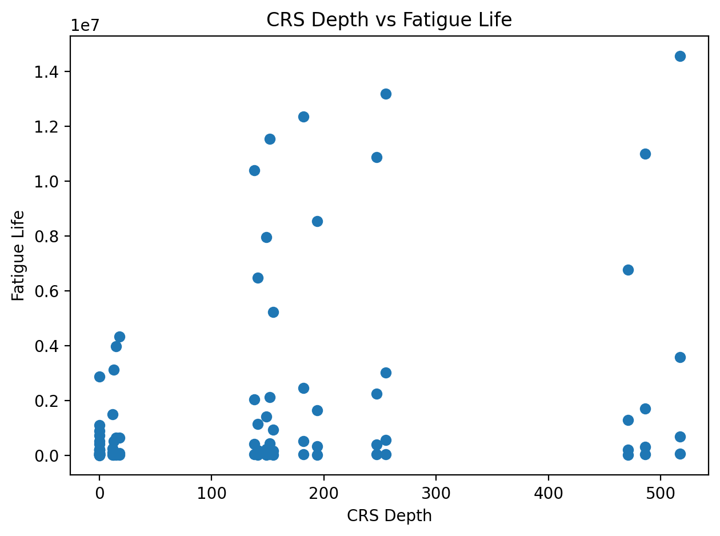
Figure 09. Compressive Residual Stress Depth vs. Fatigue Life
Figure 09 shows the relationship between the depth of the compressive residual stress layer and fatigue life. Deeper compressive stress layers are associated with longer fatigue lives, indicating that subsurface residual stress plays a critical role in delaying crack propagation. This figure demonstrates that residual stress depth is as important as residual stress magnitude for fatigue resistance.

5.3 Categorical Effects

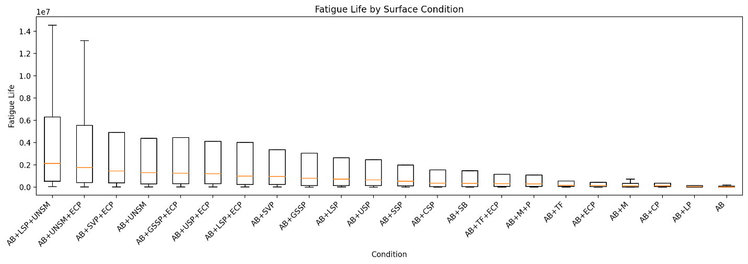
Figure 10. Fatigue life by surface post-processing condition.
Figure 10 compares fatigue life across different surface post-processing treatments. Substantial performance variation is observed, demonstrating that surface treatment selection plays a critical role in fatigue resistance.
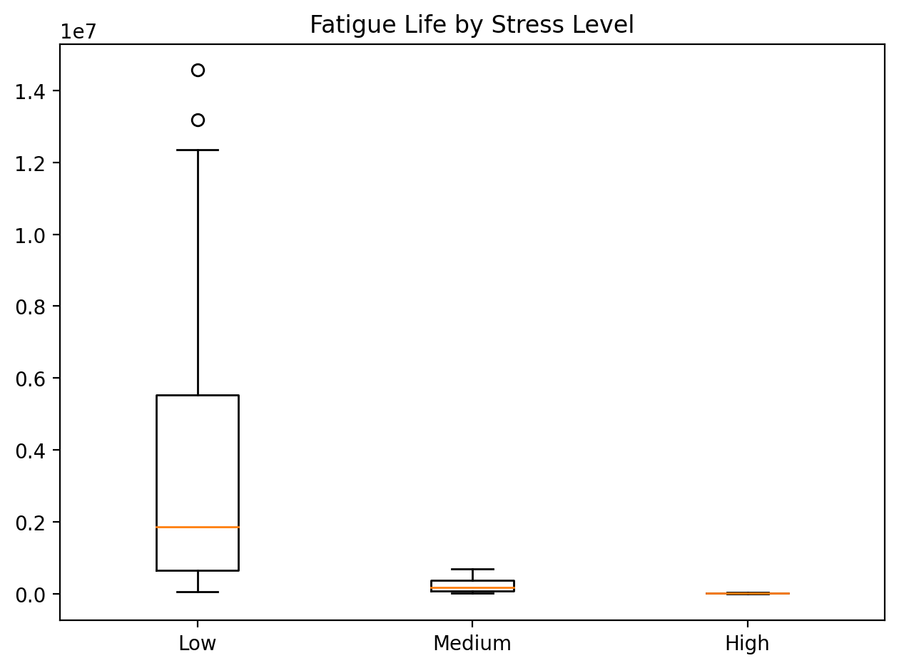
Figure 11. Fatigue Life by Stress Level
Figure 11 compares fatigue life distributions across different applied stress levels using boxplots. The figure clearly shows that increasing stress amplitude results in a pronounced reduction in fatigue life across all surface post-processing conditions. This visualization reinforces the dominant role of applied stress in fatigue behavior and provides a categorical perspective that complements continuous stress–life relationships.

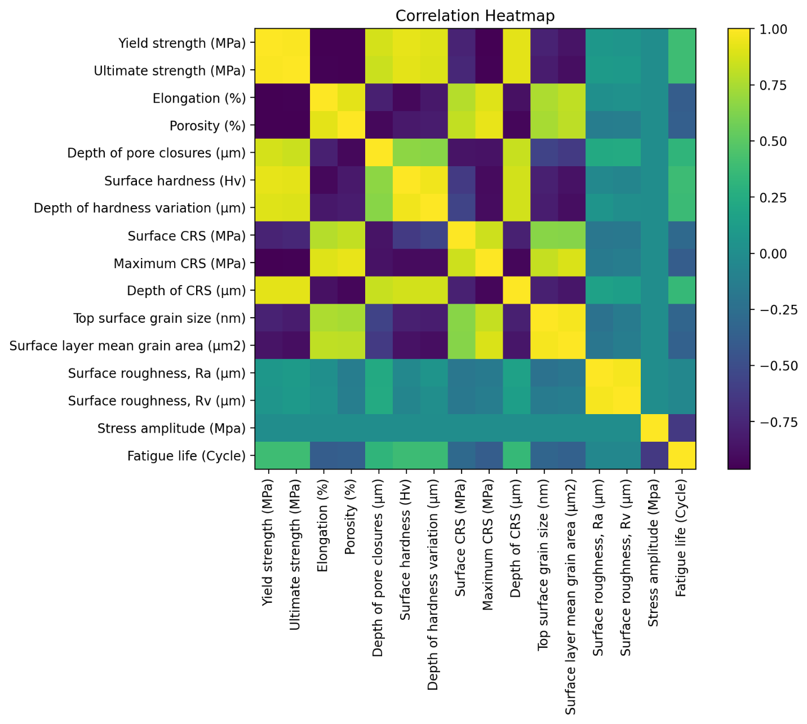
Figure 12. Correlation heatmap of numeric features.
Figure 12 presents a correlation heatmap identifying dominant dependencies among stress amplitude, surface roughness, residual stress, and fatigue life. Strong correlations support the need for multivariate modeling approaches.
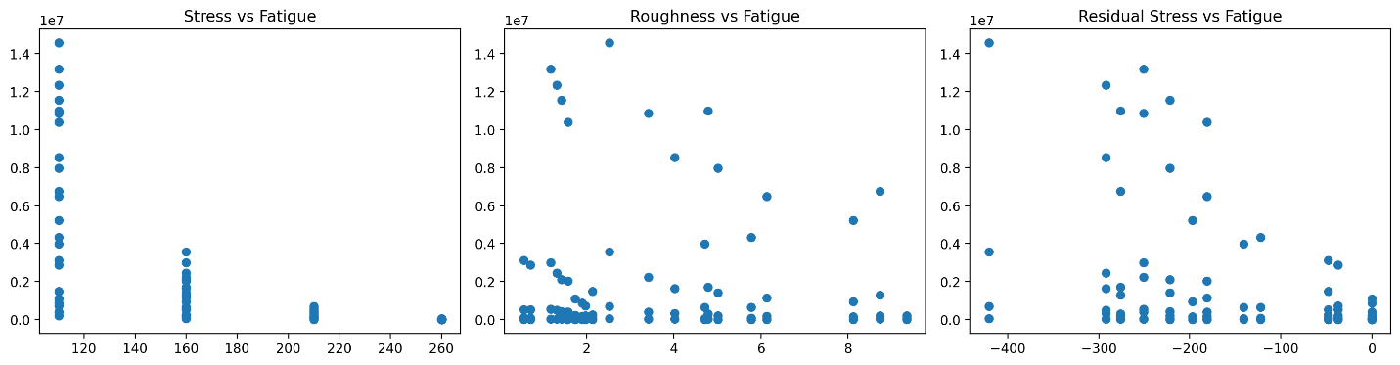
Figure 13. Subplots of key fatigue drivers.
Figure 13 consolidates the primary fatigue drivers—stress amplitude, surface roughness, and residual stress—into comparative subplots, providing an intuitive overview of their combined influence on fatigue behavior.

6. Dimensionality Reduction

6.1 Principal Component Analysis (PCA)

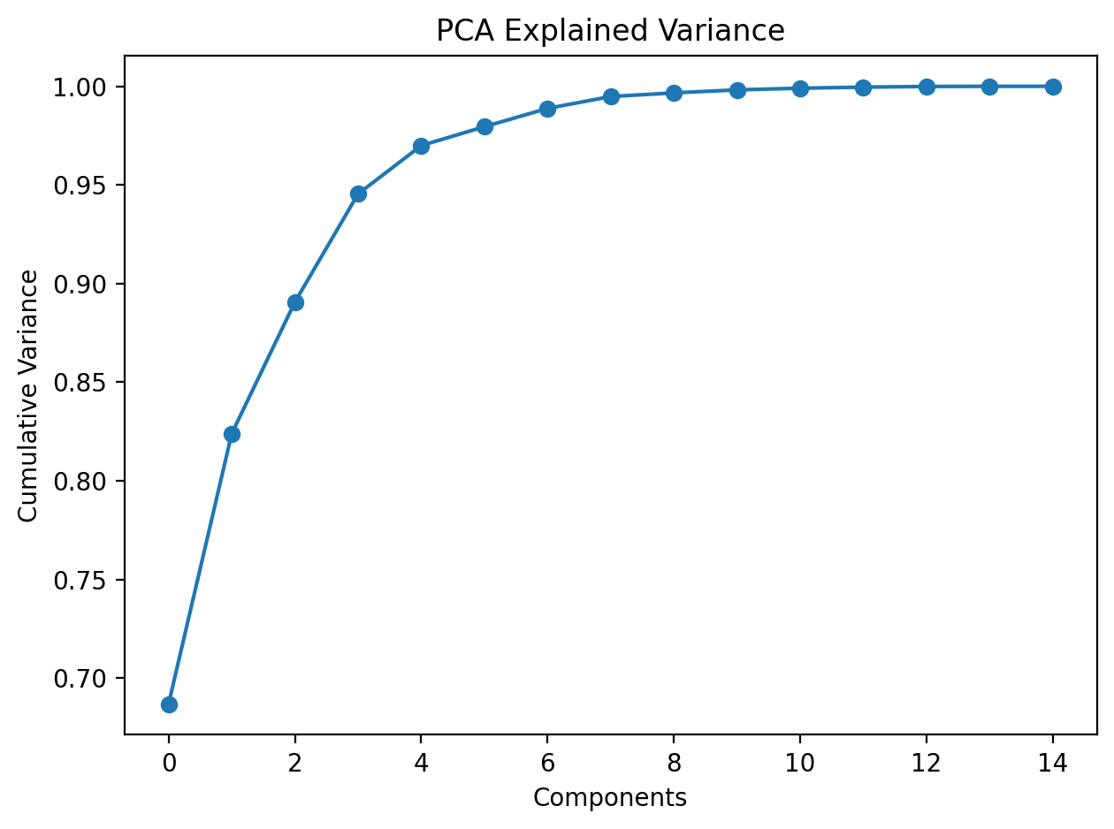
Figure 14. PCA cumulative explained variance.
Figure 14 shows that a limited number of principal components capture the majority of variance in the dataset, indicating redundancy among input features.
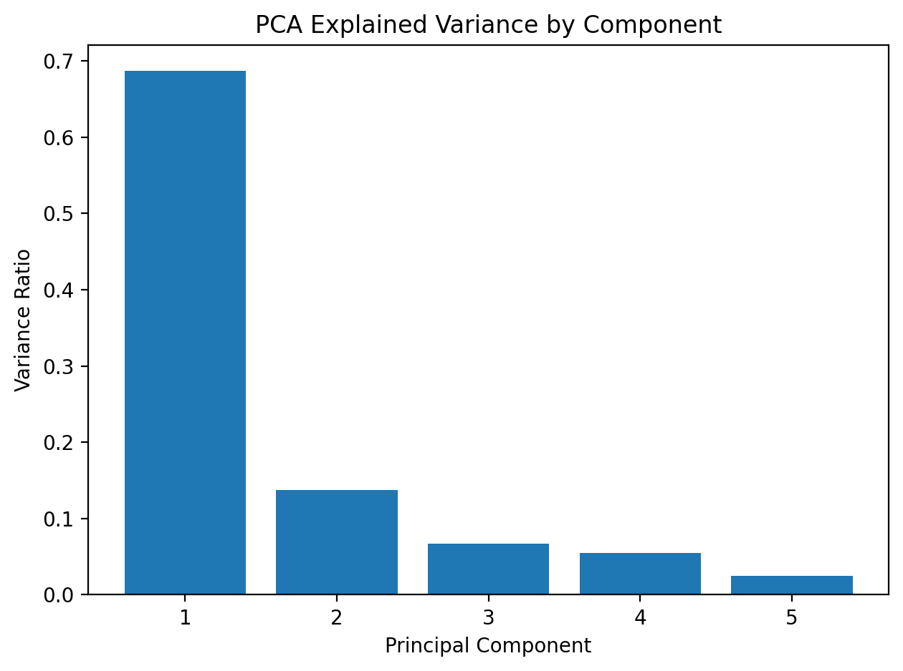
Figure 15. PCA Component Variance Contribution
Figure 15 shows the individual variance contribution of each principal component. The sharp drop in variance beyond the first few components confirms that fatigue behavior is governed by a limited number of dominant mechanisms. This supports dimensionality reduction and helps identify which combinations of surface and mechanical features drive fatigue performance.
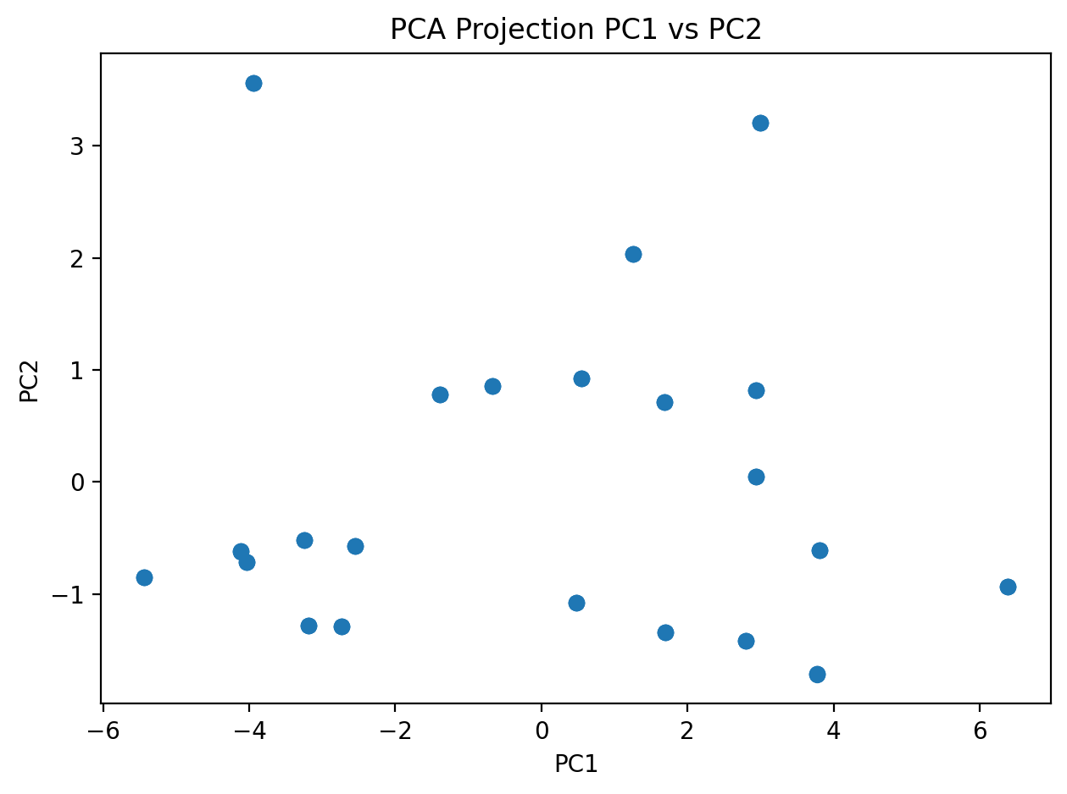
Figure 16. PCA projection (PC1 vs. PC2).
Figure 16 visualizes the projection of data onto the first two principal components, revealing clear structure and clustering tendencies driven by surface and stress-related features.

6.2 Singular Value Decomposition (SVD)
Figure 17. SVD explained variance by component.
Figure 17 identifies dominant latent contributors among surface, mechanical, and residual stress features, confirming that fatigue behavior is governed by a reduced set of underlying mechanisms.
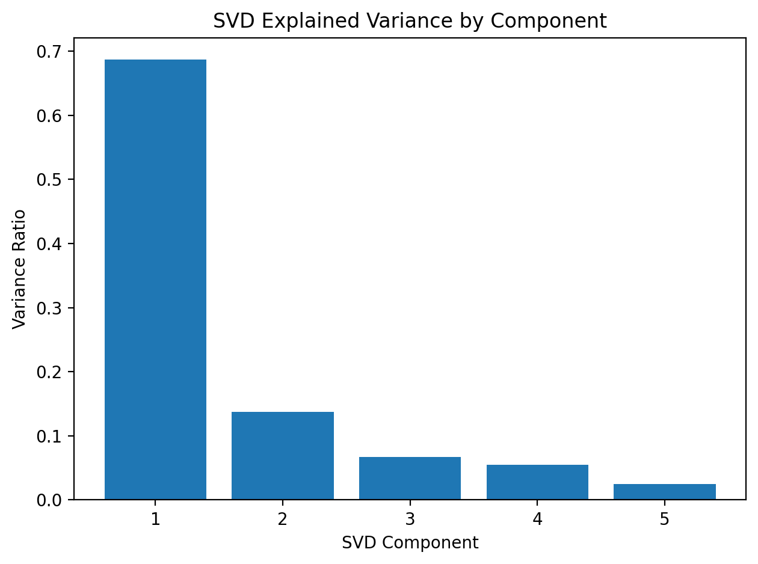
Figure 18. SVD latent structure representation.
Figure 18 further confirms redundancy reduction and reveals latent feature groupings that support dimensionality-reduced modeling.

7. Unsupervised Learning and Clustering

7.1 K-Means Clustering

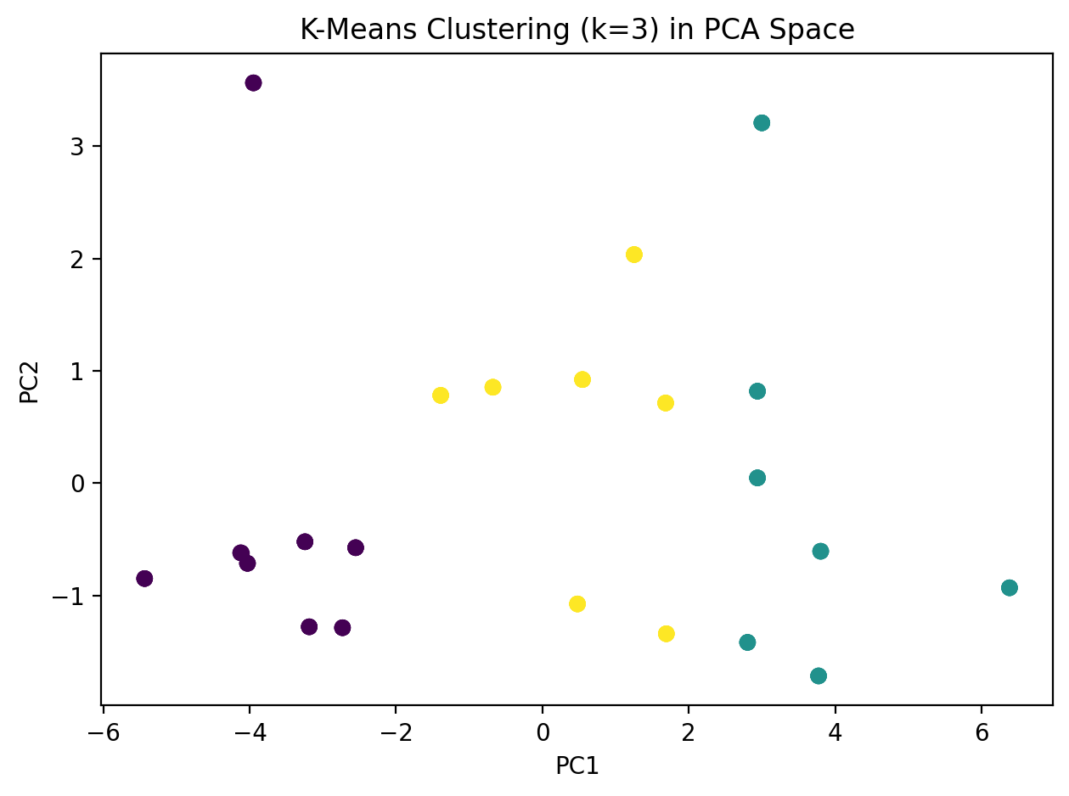
Figure 19. K-Means clustering in PCA space.
Figure 19 groups surface post-processing treatments based on fatigue performance, revealing natural clusters corresponding to low, medium, and high fatigue resistance.

7.2 DBSCAN

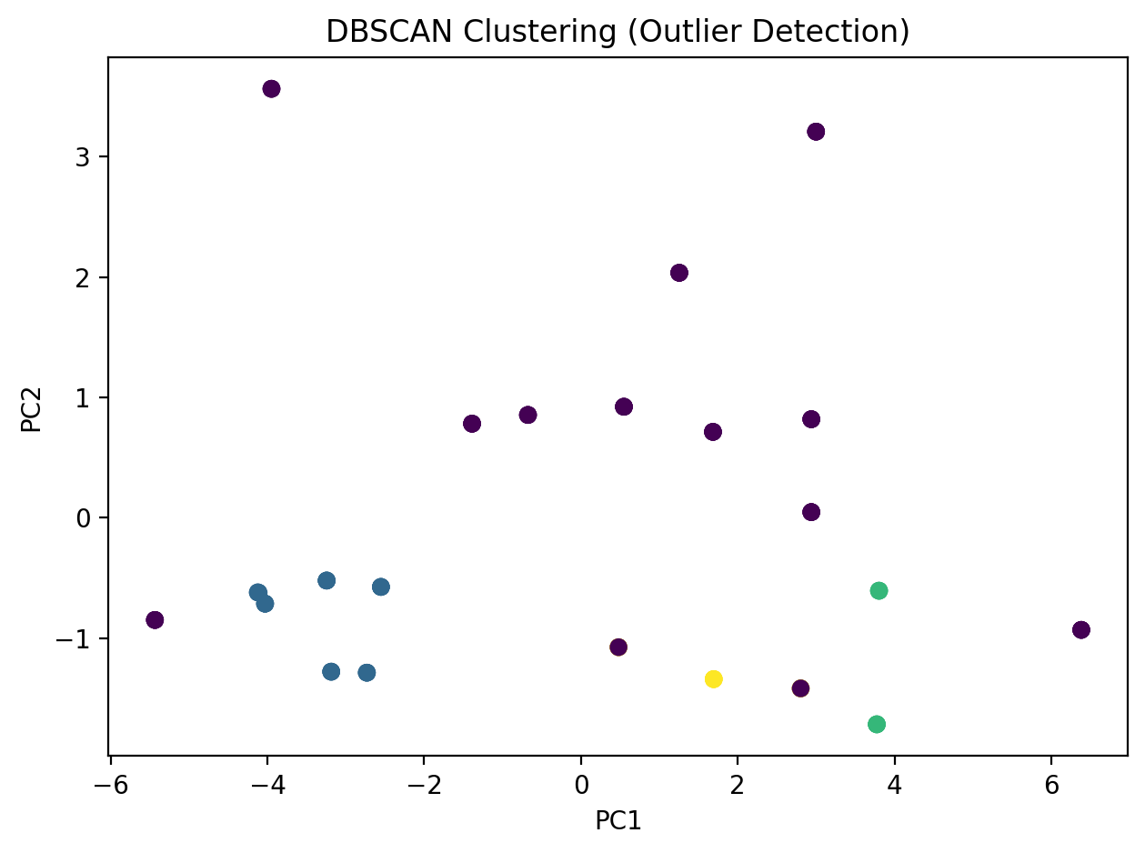
Figure 20. DBSCAN clustering and outlier detection.
Figure 20 identifies exceptional treatments and outliers that outperform typical clusters, highlighting post-processing strategies with superior fatigue performance.

7.3 Cluster Validation

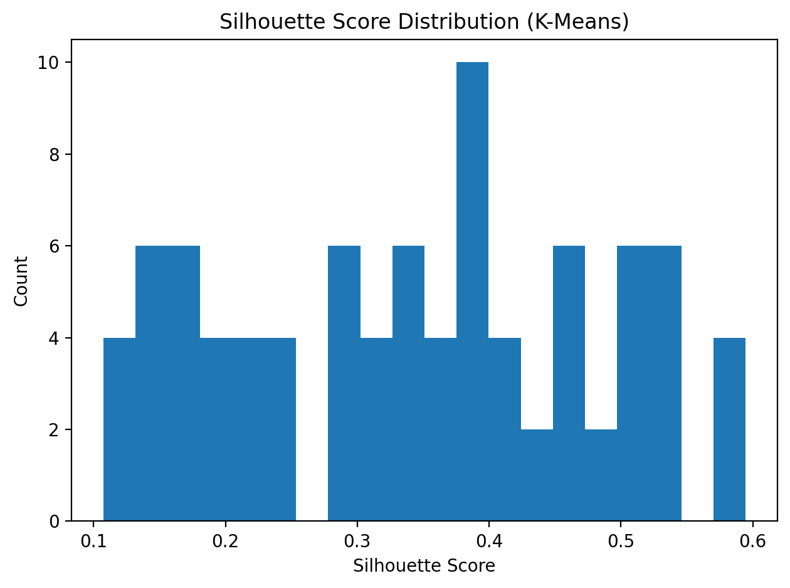
Figure 21. Silhouette score distribution.
Figure 21 presents silhouette score distributions, confirming meaningful cluster separation and validating the unsupervised clustering results.

8. Baseline Regression Modeling

8.1 Linear Regression

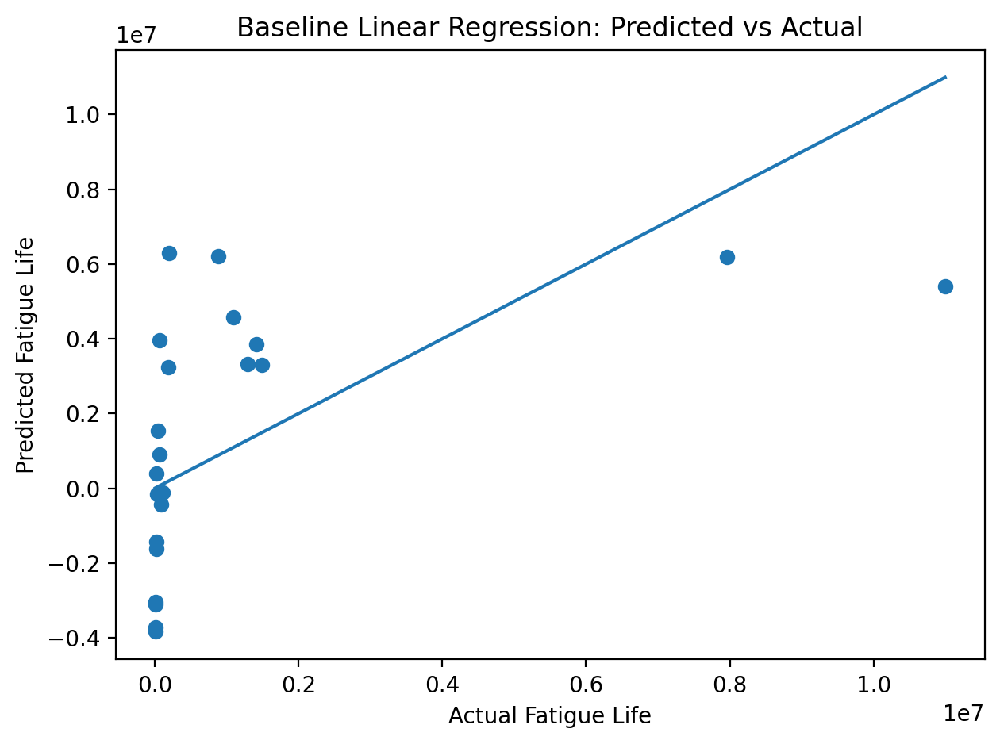
Figure 22. Baseline linear regression: predicted vs. actual fatigue life.
Figure 22 shows poor agreement between predicted and actual fatigue life for the baseline linear regression model. The low R² value confirms that linear relationships alone are insufficient to capture the complexity of fatigue behavior.

9. Nonlinear Regression and Predictive Modeling

9.1 Random Forest and Gradient Boosting

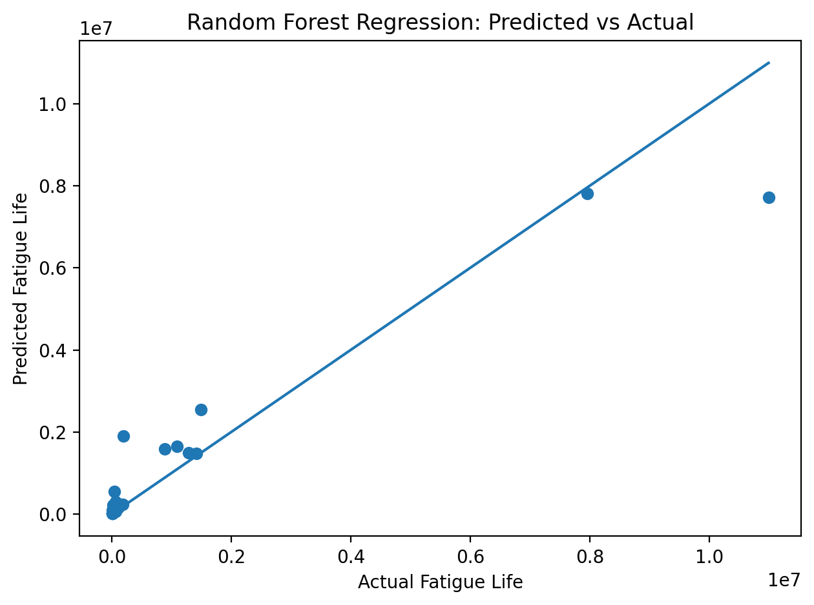
Figure 23. Random Forest regression: predicted vs. actual fatigue life.
Figure 23 demonstrates substantial improvement in predictive accuracy when nonlinear interactions are captured using Random Forest regression.
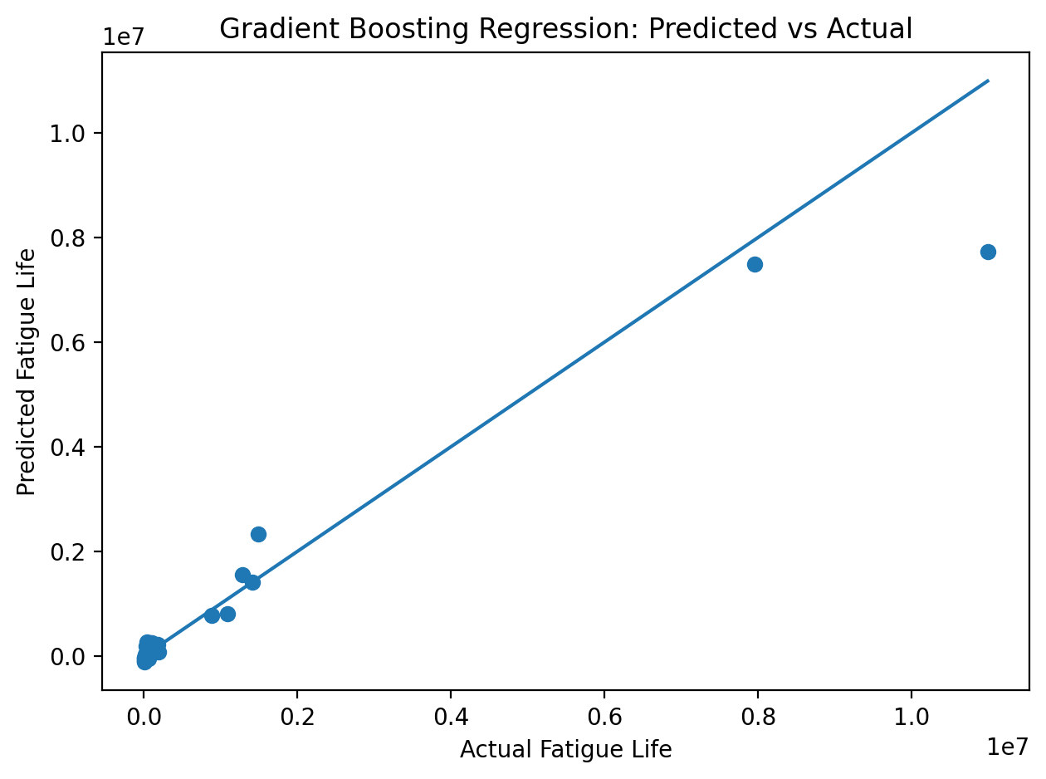
Figure 24. Gradient Boosting regression: predicted vs. actual fatigue life.
Figure 24 shows further enhancement in prediction accuracy using Gradient Boosting, particularly at higher fatigue life values.
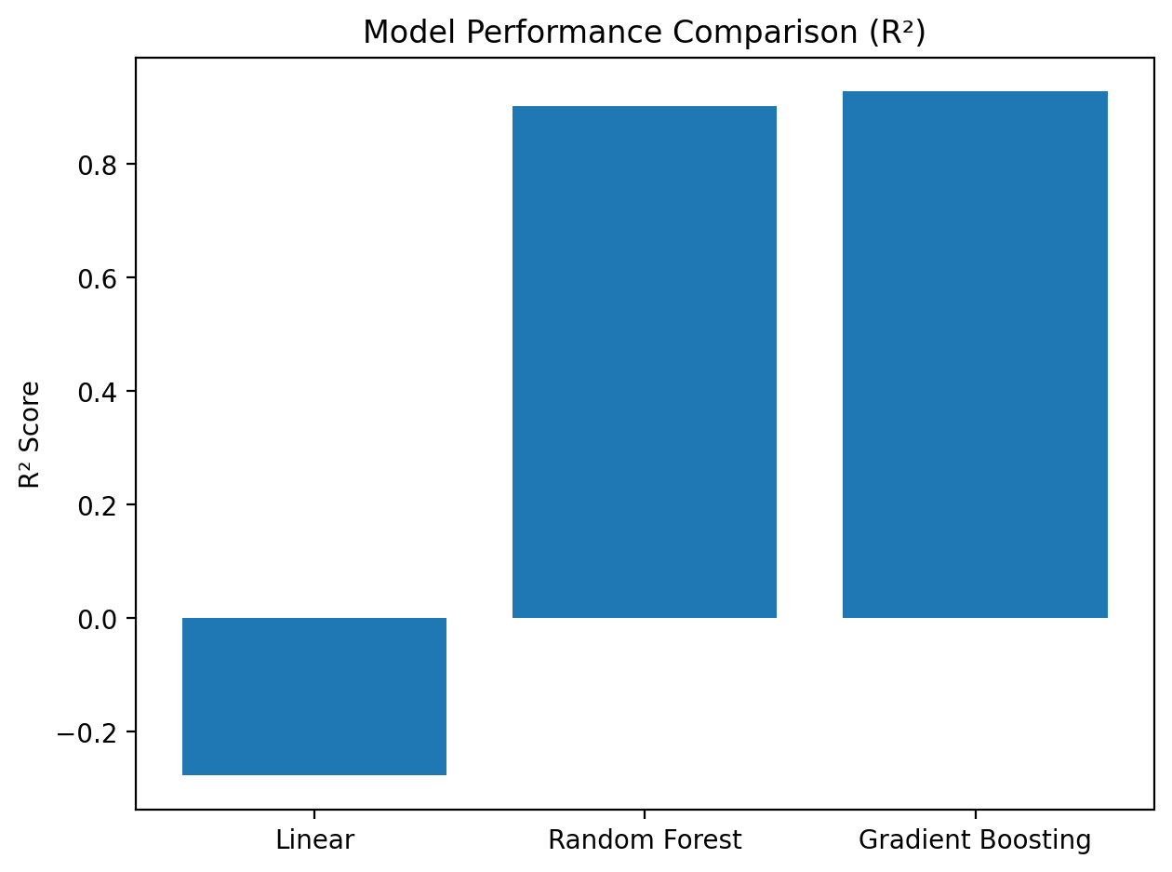
Figure 25. Model performance comparison (R²).
Figure 25 directly compares R² values across linear and nonlinear models, confirming the superior performance of nonlinear approaches.

9.2 Model Diagnostics

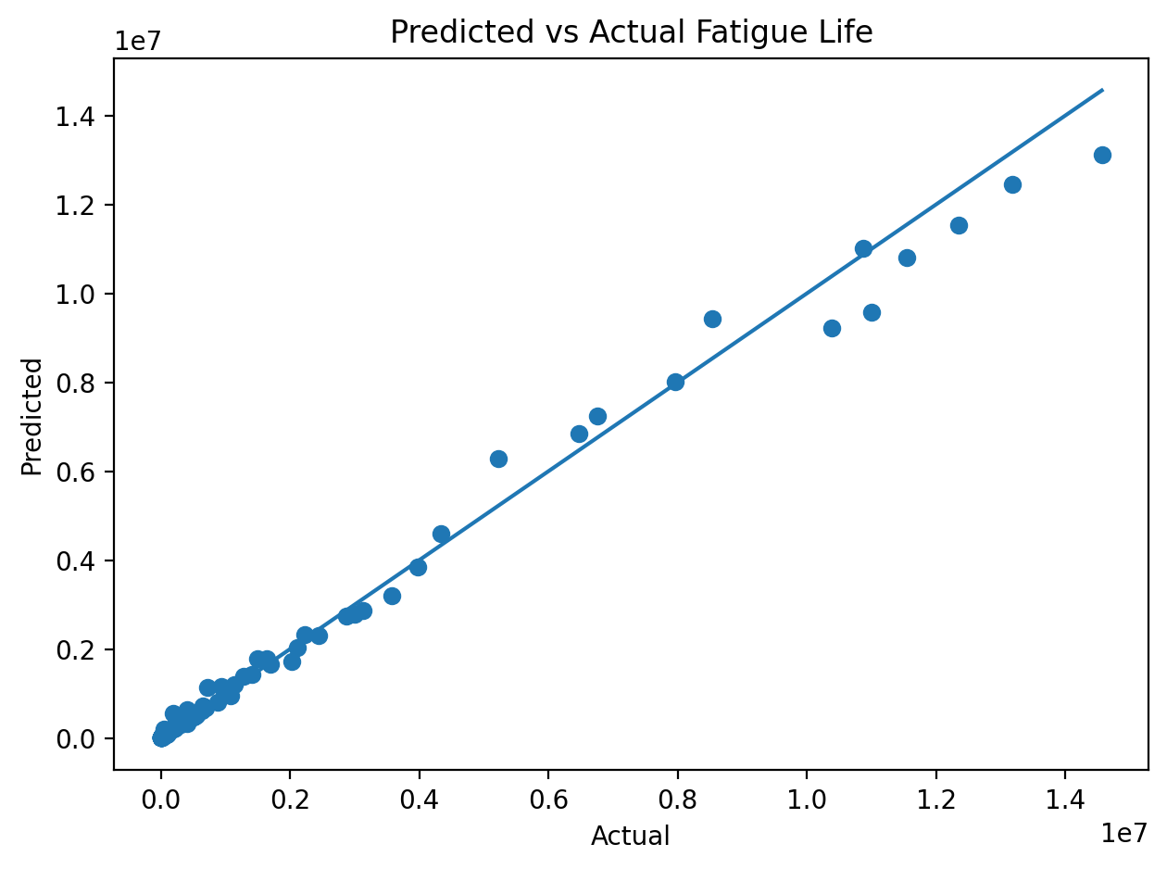

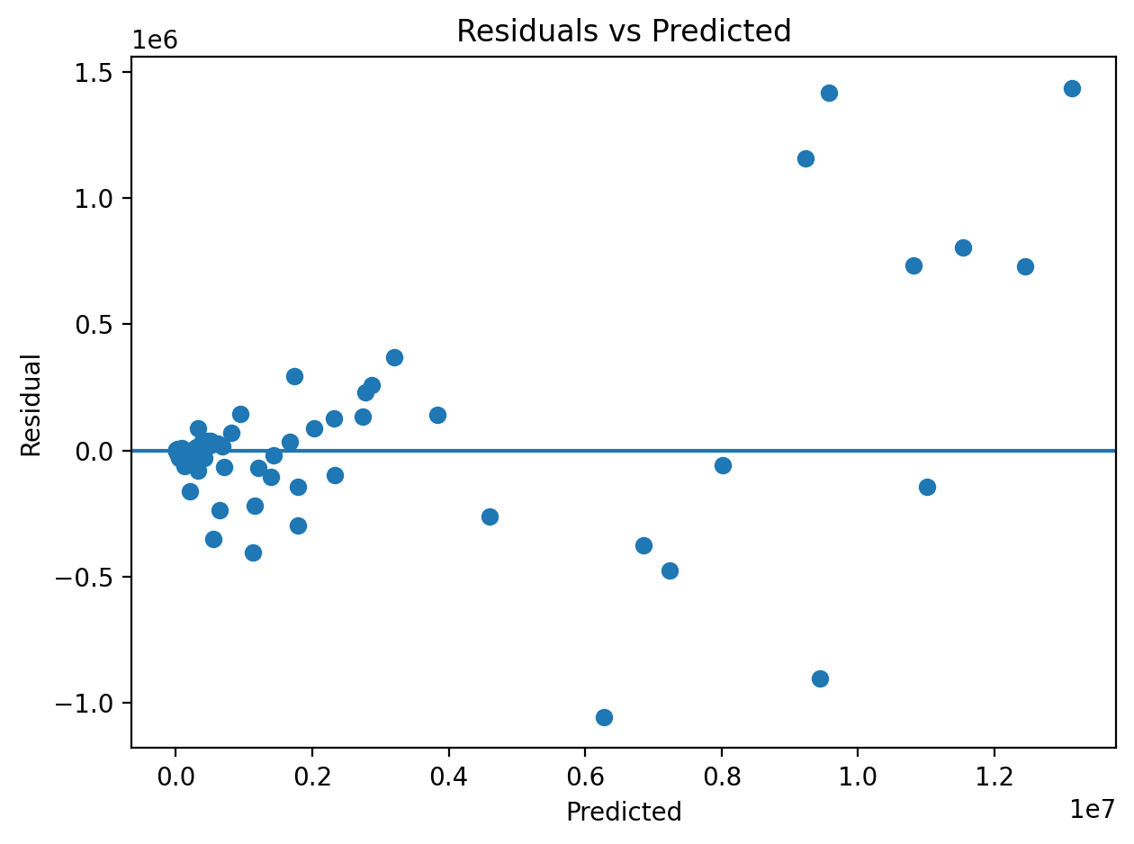

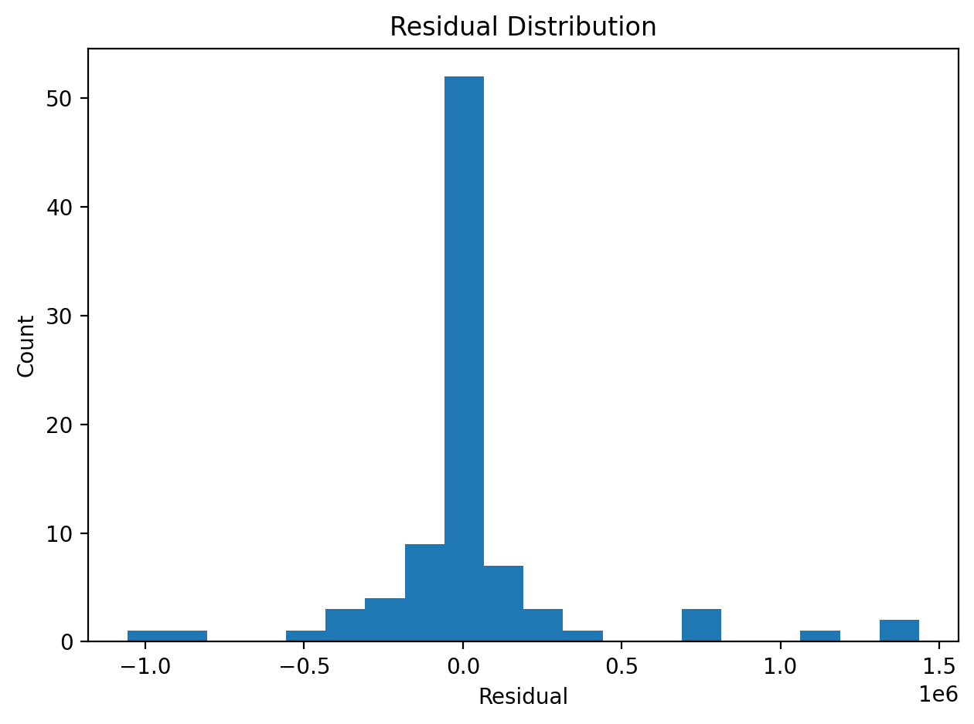
Figures 26-28. Prediction diagnostics and residual analysis.
Figures 26 through 28 evaluate prediction accuracy, residual behavior, and error distribution, confirming stable model performance and absence of systematic bias.
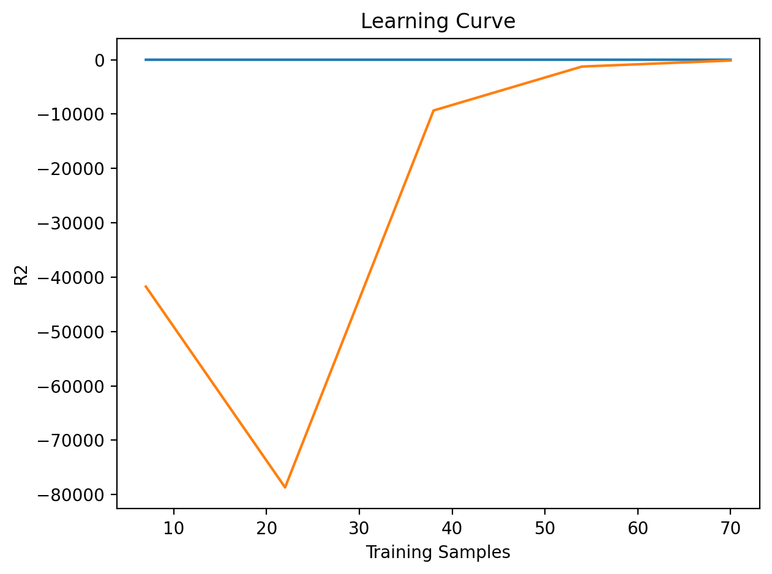
Figure 29. Learning curve.
Figure 29 presents learning curves, indicating good generalization behavior and no significant overfitting.

9.3 Feature Importance

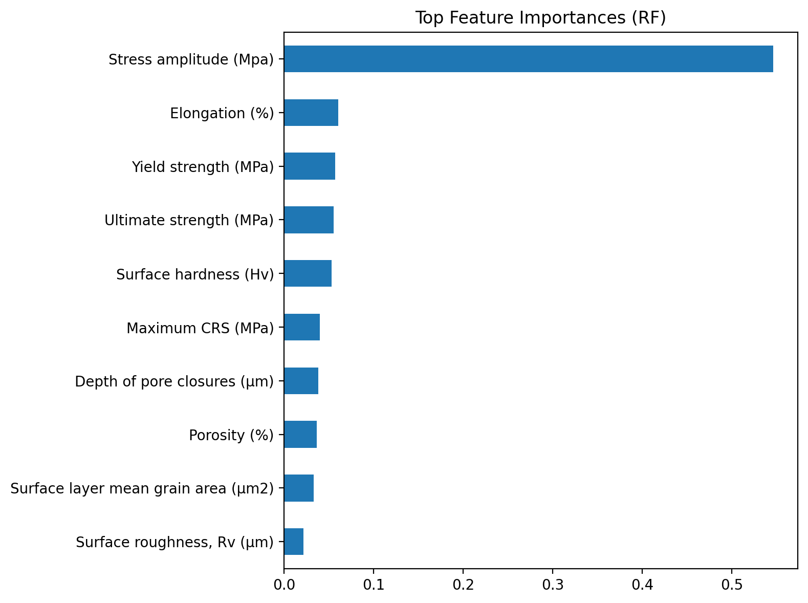

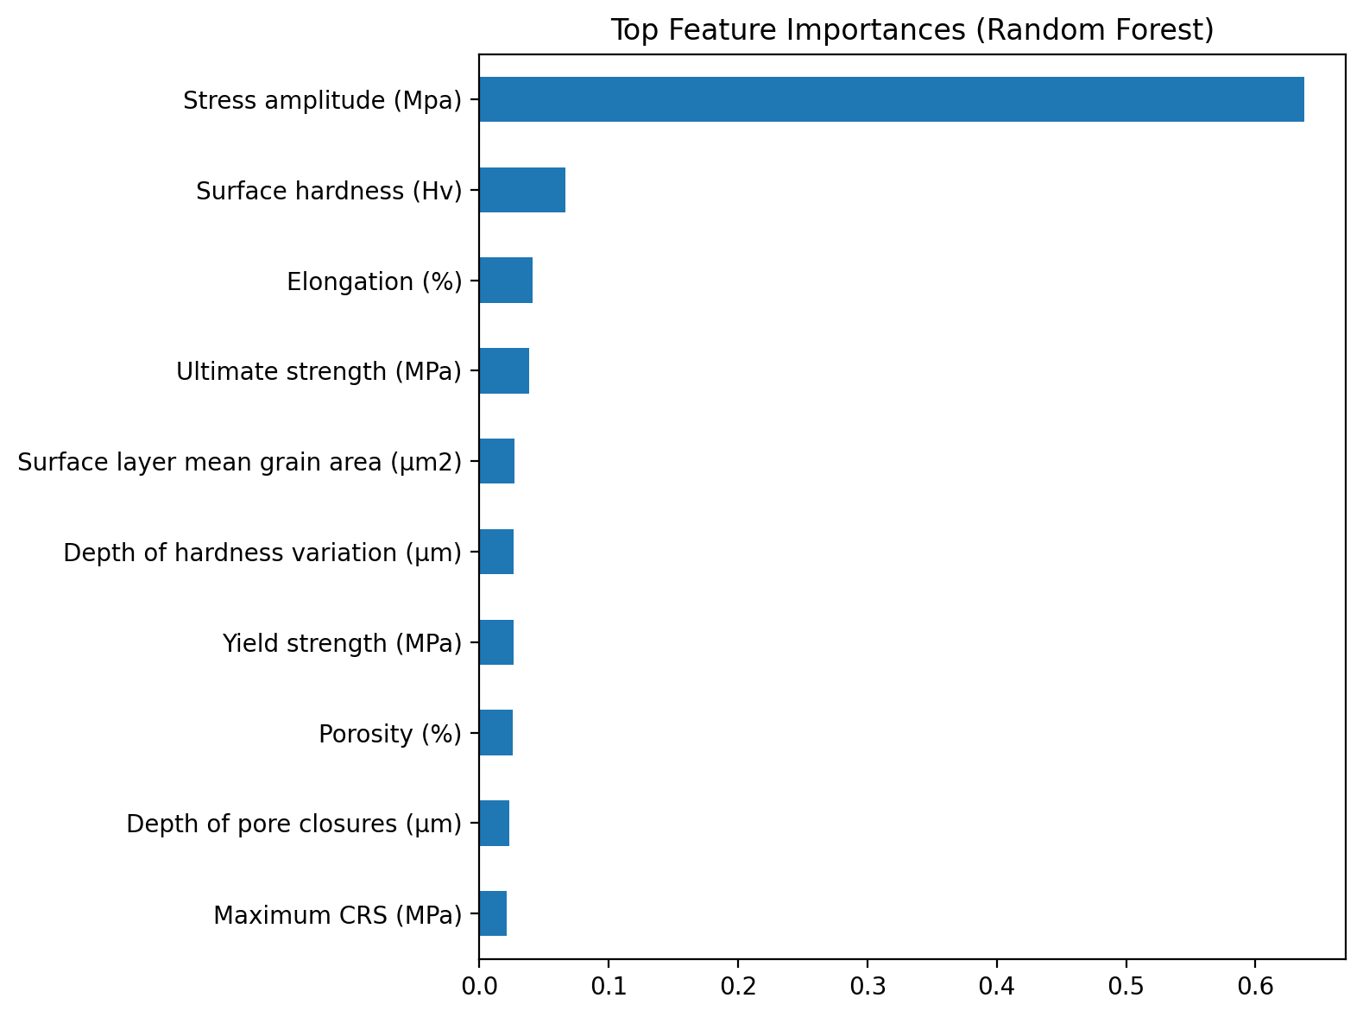
Figures 30 and 31. Feature importance rankings.
Figures 30 and 31 highlight stress amplitude, surface roughness, residual stress, and surface hardness as the dominant predictors of fatigue life.

10. Regularization and Cross-Validation

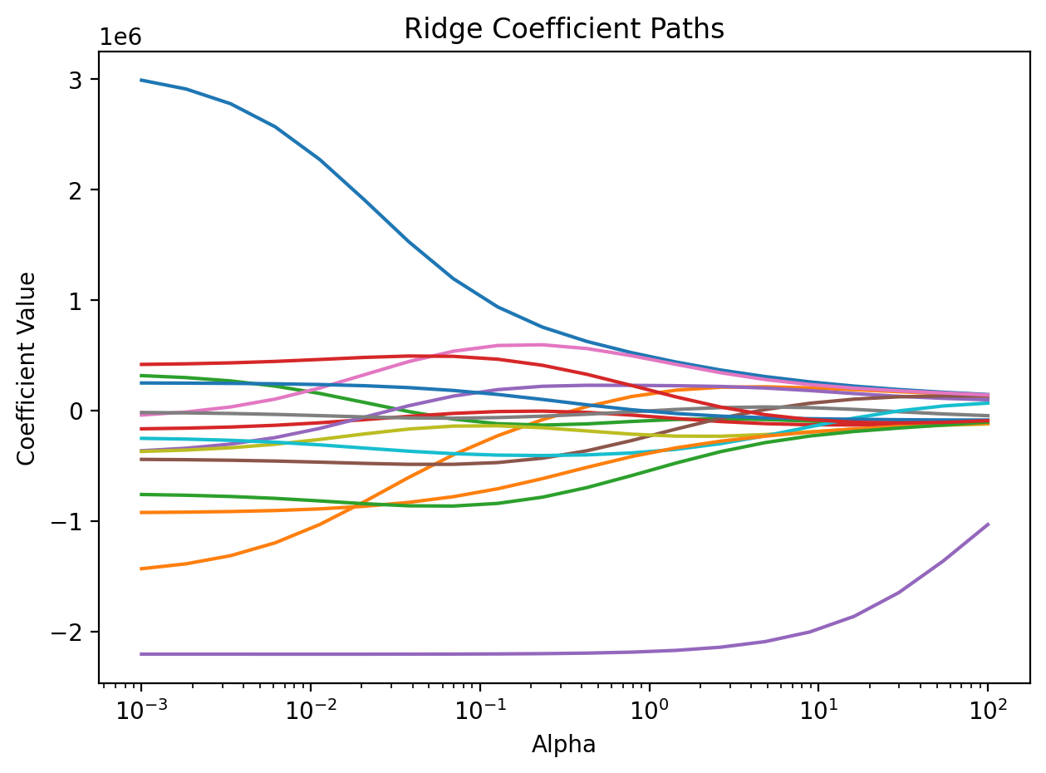

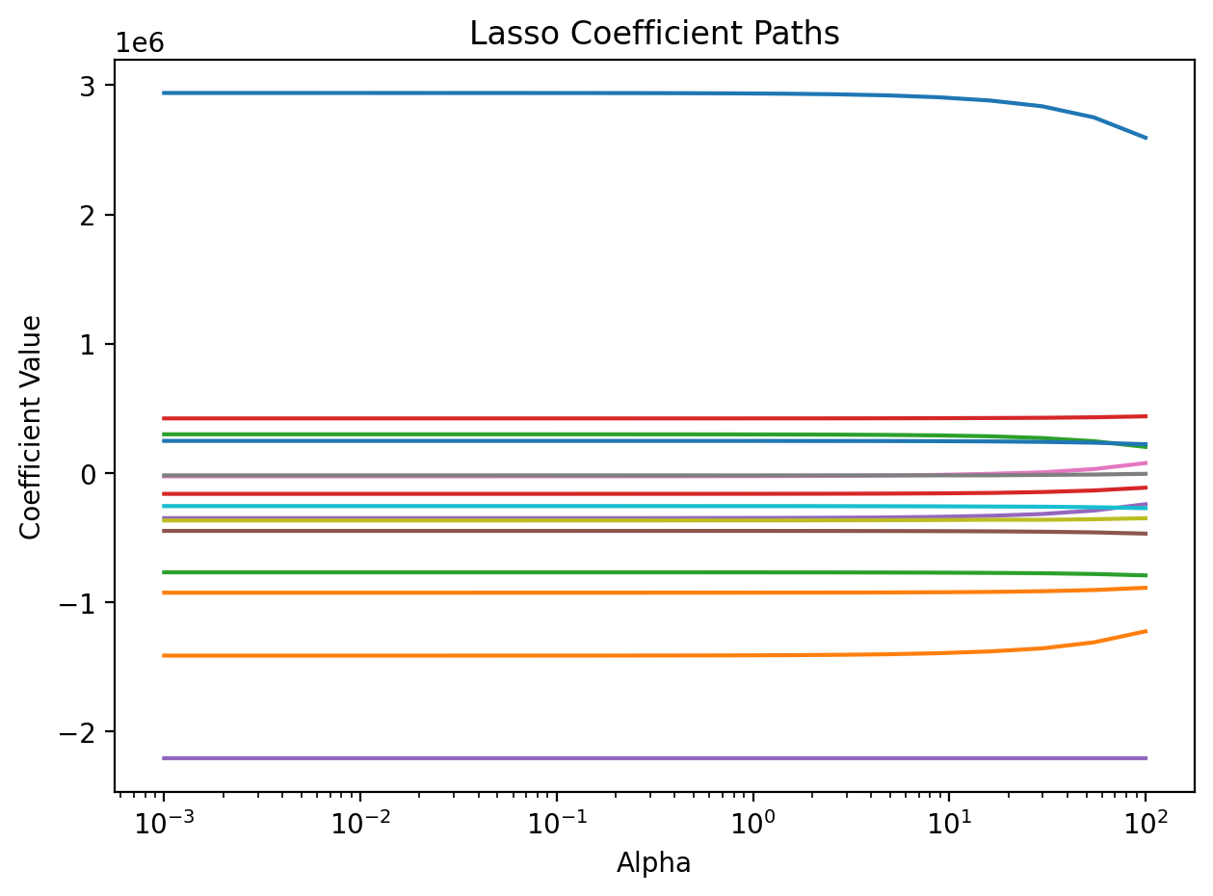
Figures 32 and 33. Ridge and Lasso coefficient paths.
Figures 32 and 33 illustrate coefficient shrinkage and sparsity enforcement, confirming effective overfitting control through regularization.
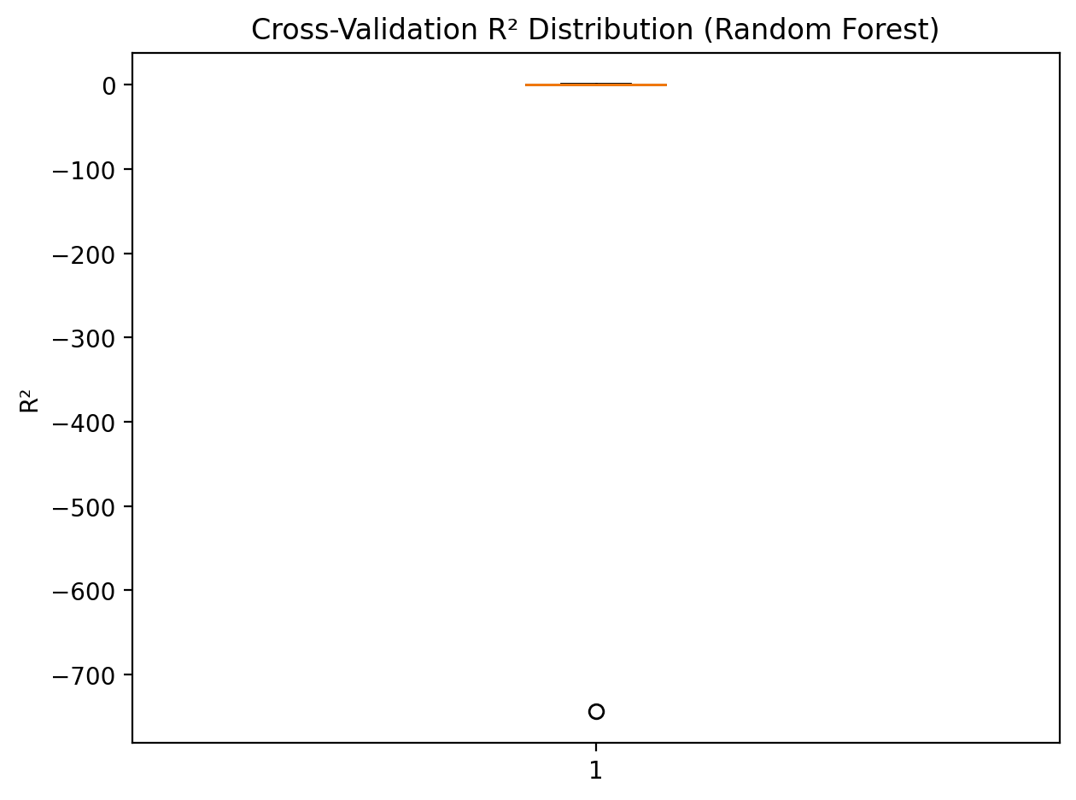
Figure 34. Cross-validated R² distribution.
Figure 34 demonstrates robust model reliability across multiple folds.

11. Classification and Fatigue Tier Analysis

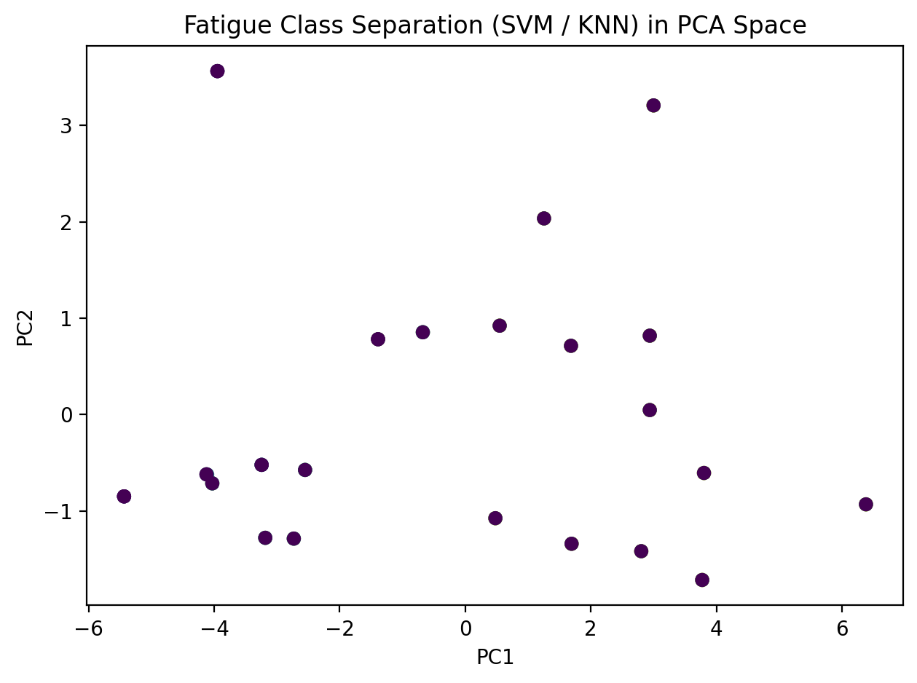
Figure 35. Fatigue tier classification in PCA space.
Figure 35 visualizes separation of low, medium, and high fatigue-performance tiers using SVM and KNN models, validating classification-based fatigue screening.

12. Optimization and Model Tuning

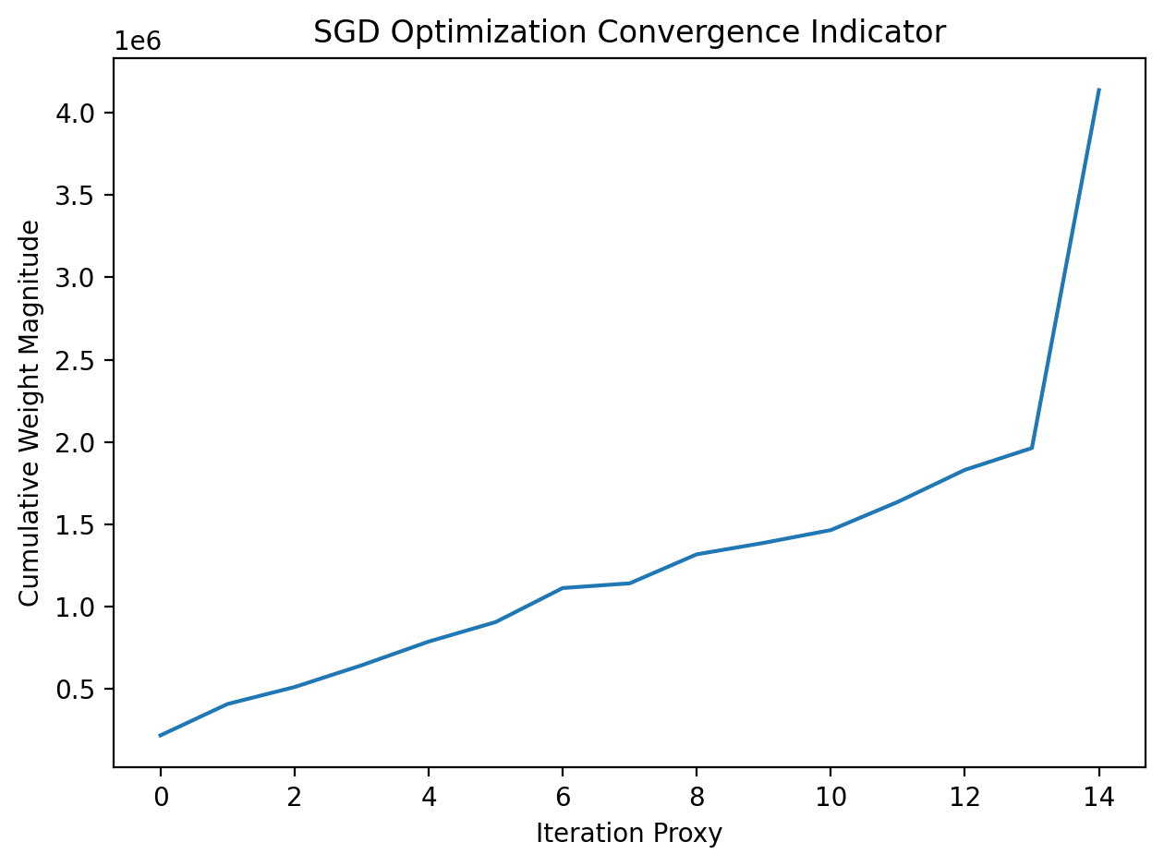
Figure 36. Optimization convergence using SGD.
Figure 36 illustrates convergence behavior during optimization, confirming stable parameter updates and effective loss minimization.

13. Key Findings
Stress amplitude is the strongest driver of fatigue life.
Across all post-processing conditions and surface states, the applied stress amplitude consistently showed the largest influence on fatigue life. As stress amplitude increases, fatigue life decreases sharply, regardless of surface treatment. This confirms well-established fatigue principles while also validating the reliability of the experimental dataset. Importantly, machine learning models were able to quantify how stress interacts with surface and residual stress features rather than acting in isolation.
Surface roughness governs crack initiation behavior.
Surface roughness parameters, particularly average roughness (Ra), play a critical role in fatigue performance by controlling crack initiation. Rougher surfaces introduce micro-notches that locally amplify stress and act as preferred crack initiation sites. Even when bulk mechanical properties remain unchanged, variations in surface roughness lead to large differences in fatigue life. This finding explains why certain post-processing treatments significantly outperform others despite similar material strength.
Compressive residual stress magnitude and depth significantly delay crack growth.
Residual stress features—specifically the magnitude of compressive residual stress and the depth of the compressive layer—were found to strongly enhance fatigue resistance. Compressive residual stresses counteract applied tensile loading, slowing crack propagation after initiation. Treatments that introduced deep and stable compressive stress fields consistently resulted in helping to achieve longer fatigue life, highlighting the importance of subsurface stress engineering rather than surface smoothing alone.
Bulk mechanical properties alone are insufficient predictors without surface information.
Traditional fatigue assessment often relies on bulk properties such as yield strength or ultimate tensile strength. This study shows that while these properties are important, they cannot reliably predict fatigue performance on their own. Two specimens with similar strength can exhibit drastically different fatigue lives if their surface condition or residual stress state differs. This underscores the need for holistic models that integrate surface, residual stress, and mechanical information.
Nonlinear machine learning models dramatically outperform linear baselines.
Baseline linear regression models captured only limited trends and produced low predictive accuracy, confirming that fatigue behavior is inherently nonlinear. In contrast, nonlinear models such as Random Forest and Gradient Boosting captured complex interactions between stress amplitude, surface roughness, residual stress, and hardness. These models achieved substantially higher predictive performance, demonstrating the necessity of nonlinear learning approaches for fatigue prediction in additively manufactured materials.

14. Practical Impact
This project demonstrates how machine learning can provide tangible value to both engineering practice and industrial decision-making:
- Reduce experimental fatigue testing cost:
By identifying the most influential features governing fatigue life, machine learning models can reduce the number of required fatigue experiments. This enables targeted testing rather than exhaustive trial-and-error campaigns.
- Support data-driven surface treatment selection:
The framework allows engineers to compare post-processing treatments quantitatively, rather than relying on intuition or isolated test results. Treatments can be selected based on predicted fatigue performance under specific loading conditions.
- Improve confidence in fatigue-critical AM designs:
Integrating surface, residual stress, and mechanical data into predictive models increases confidence when deploying AM components in safety-critical applications. This supports more reliable design allowables and performance margins.
- Enable scalable qualification and certification workflows:
The developed workflow demonstrates a pathway toward scalable qualification strategies, where experimental data, machine learning models, and engineering knowledge are combined to support certification-ready documentation.

15. Next Steps and Recommendations
Several opportunities exist to extend and strengthen the presented framework:
- Expand the dataset to additional alloys and build orientations:
Including other AM alloys and build orientations would improve model generalizability and enable broader applicability across AM platforms.
- Integrate in-situ monitoring data:
Incorporating process monitoring signals (e.g., melt pool signatures, thermal history) could enable early prediction of fatigue performance during fabrication rather than post-testing.
- Deploy trained models as decision-support tools:
The developed models can be implemented as user-friendly tools to assist engineers in selecting post-processing treatments and predicting fatigue life during design.
- Extend the framework toward certification-ready digital twins:
Combining experimental data, machine learning, and physics-based understanding offers a pathway toward digital twins that support qualification, certification, and lifecycle management of AM components.

